Valley Forge Tourism Board’s Freedom from Hunger Food Drive is underway
The goal for this year is to raise the monetary equivalent of 180,000 pounds of food
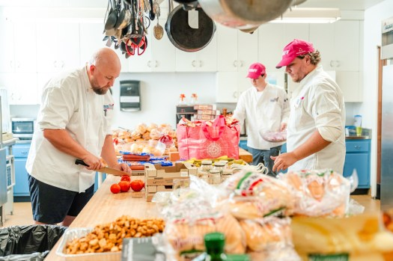
Staff members from the Valley Forge Tourism and Convention Board prep food for the launch of the agency’s annual Freedom from Hunger Food Drive, on Friday, Aug. 15, at Emmanuel Lutheran Church in Pottstown. (Courtesy Valley Forge Tourism and Convention Board)

By Donna Rovins | drovins@pottsmerc.com | Reading Eagle
PUBLISHED: August 19, 2025 at 6:15 AM EDT
The Valley Forge Tourism and Convention Board has kicked off its 11th annual Fall Freedom from Hunger Food Drive, an initiative to build awareness about food insecurity and the increased need in Montgomery County.
This year’s drive kicked off on Friday, Aug. 15, with a kitchen takeover at Emmanuel Lutheran Church in Pottstown. Representatives from the tourism board, along with Montgomery County Commissioners Jamila Winder and Tom DiBello, cooked and served a lunch of hamburgers, hot dogs and ice cream to more than 60 guests. The food was donated by HUNGRY Catering, and the ice cream was donated by Merrymead Farm in Lansdale.
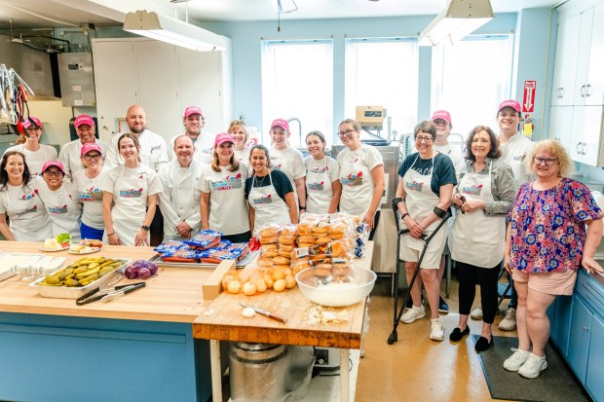The Valley Forge Tourism and Convention Board kicked off its annual Freedom from Hunger Food Drive with a kitchen takeover at Emmanuel Lutheran Church in Pottstown on Aug. 15. The volunteers prepared and served lunch for more than 60 guests. The drive raises funds to build awareness about food insecurity in Montgomery County. (Courtesy Valley Forge Tourism and Convention Board)
The Valley Forge Tourism and Convention Board is once again partnering with the Montco Anti-Hunger Network (MAHN) — a coalition of hunger relief organizations working together to keep families stable with food assistance.
The goal for this year’s fall drive is to collect $15,000, or the equivalent of 180,000 pounds of food, which will be used to support more than 70 food pantries and soup kitchens through the Montco Anti-Hunger Network, the tourism board said in a press release. The facilities serve more than 85,000 households experiencing food insecurity in Montgomery County.
“The leadership Valley Forge Tourism and Convention Board is providing regarding working against hunger is more essential than ever,” Shannon Isaacs, executive director for MAHN, said in a statement. “Initiatives like this show that it is possible to make sure all members of our community have enough in Montgomery County if we all work together.”
In 2024, 52% of food pantries surveyed by MAHN said they did not have enough food to serve every guest. Ten percent reported meeting only half or less of the demand, according to the release.
00:00
00:00
Read More
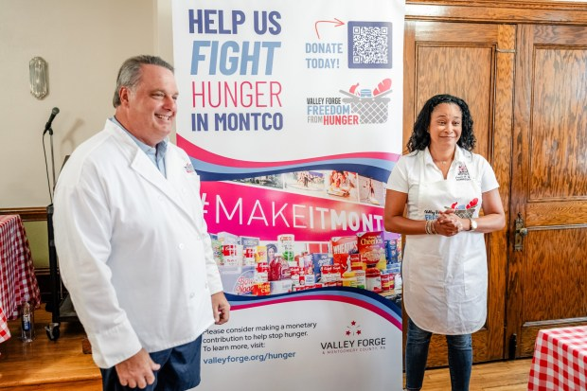Montgomery County Commissioners Tom DiBello, left, and Jamila Winder, right, help to kick off the Valley Forge Tourism and Convention Board’s annual Freedom from Hunger Food Drive on Friday, Aug. 15. (Courtesy Valley Forge Tourism and Convention Board)
“The need is greater than ever, and this drive helps fill the shelves and the plates for those who need it most,” Jamila Winder, vice chairwoman of the Montgomery County Board of Commissioners, said in a statement. “It’s so important that we have these types of events because we know we have many friends and neighbors throughout Montgomery County that are food insecure.”
“Right now, there are 85,000 people in Montgomery County that experience food insecurity every year — that’s our friends, coworkers and neighbors,” DiBello said in a statement. “Our goal with the Freedom from Hunger Food Drive is to take one big bite out of hunger.”
The Freedom from Hunger Drive was first launched in 2015 and has become an important event on Valley Forge Tourism’s fall events calendar. It was originally launched as a pledge to Pope Francis when the late pontiff stayed in Montgomery County during the World Meeting of Families in Philadelphia.
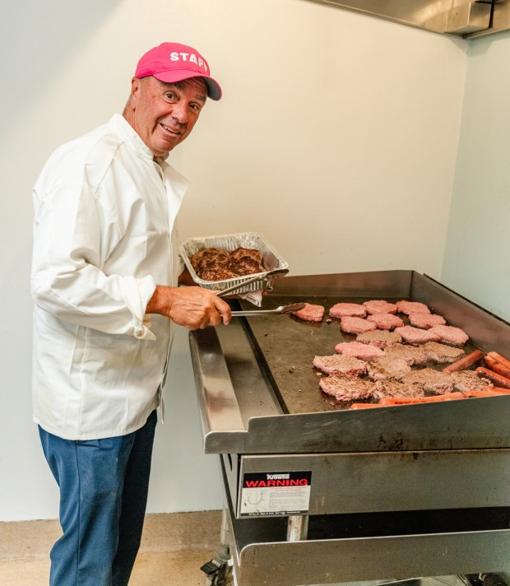Mike Bowman, president and CEO of the Valley Forge Tourism and Convention Board, cooks hamburgers and hot dogs for the kick-off of the agency's annual Freedom from Hunger Food Drive on Friday, Aug. 15, at Emmanuel Lutheran Church in Pottstown. (Courtesy Valley Forge Tourism and Convention Board)
Since the drive was first launched, the tourism board has collected the equivalent of more than 500,000 pounds of food to feed the hungry in Montgomery County. Last year’s goal of collecting the monetary equivalent of 90,000 pounds of food was crushed. Instead, the monetary equivalent of 154,188 pounds of food — or $12,849 — was raised.
In addition to donations from area residents, several area businesses are once again supporting the initiative either by donating directly to the drive or through sales proceeds through the end of October.
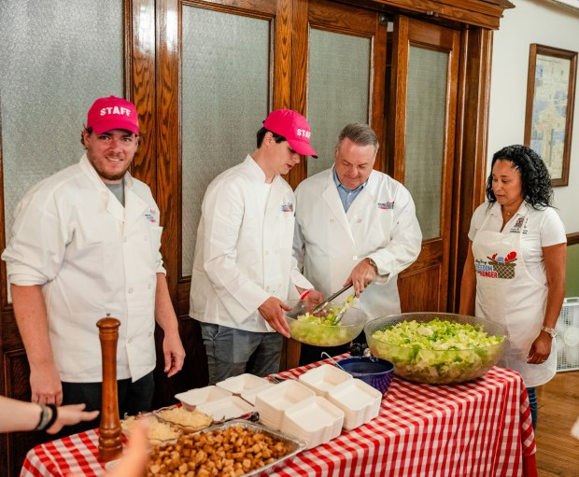Montgomery County Commissioners Tom DiBello, third from left and Jamila Winder, right, work with Valley Forge Tourism and Convention Board staff to prepare to serve more than 60 guests at Emmanuel Lutheran Church in Pottstown on Friday, Aug. 15. The event marked the kickoff of the tourism board’s annual food drive. (Courtesy Valley Forge Tourism and Convention Board)
Freedom from Hunger has been nominated as a beneficiary of The Purpose Project during the Playeasy Innovators Summit, the agency said. Through the initiative, Playeasy will donate $4,000 to the Freedom from campaign, the equivalent of 48,000 pounds of food for those in need.
“The need is greater than ever, and that’s exactly what the Freedom from Hunger drive is about, making sure no neighbor goes without. We hope this inspires even more businesses and individuals to join us in meeting this urgent call to care,” Rachel Riley, vice president of marketing & communications for the Valley Forge Tourism and Convention Board and a board member for the MontCo Anti-Hunger Network, said in a statement.
A full listing of participating businesses can be viewed by visiting the Freedom from Hunger website.
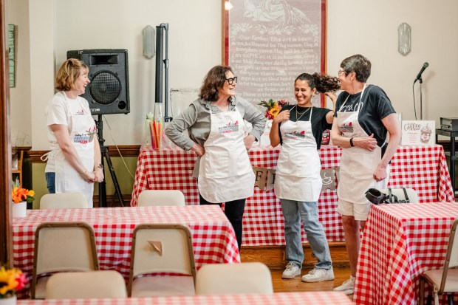From left to right are: Linda Brumbaugh from the Valley Forge Tourism and Convention Board; Jane Bugg, Montco Anti-Hunger Network administrator; Layla Malik, Montco Anti-Hunger Network Innovation Coordinator; and Mindy Bartscherer, Montco Anti-Hunger Network board president. (Courtesy Valley Forge Tourism and Convention Board)
Since 2020, the Freedom from Hunger Food Drive has been conducted completely online — rather than by physically collecting food. The drive will run through the end of October. Donations are being accepted at https://www.valleyforge.org/hunger/.
What is now known as the MontCo Anti-Hunger Network was founded in 2014 to help food pantries share food with each other and strengthen the food safety net in Montgomery County, according to information on the organization’s website. Since then, MAHN has contributed to county food safety net resilience by leading coordinated action among a network of 73 food pantries, food banks, and free meal providers. In 2024, 890,000 pounds of food were delivered. Since 2022, the MAHN has seen a 113% increase in food delivered.
For information, visit https://www.montcoantihunger.org/.
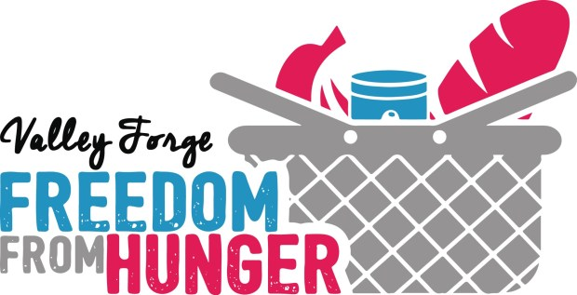(Courtesy Valley Forge Tourism and Convention Board)
- Facebook
- X

Most Popular
Most Popular
- Pottstown man, ‘principal’ in gun trafficking network, enters no contest plea
Pottstown man, ‘principal’ in gun trafficking network, enters no contest plea
- U.S. Attorney names Pottstown nursing facility in federal complaint
U.S. Attorney names Pottstown nursing facility in federal complaint
- State police order 'immediate evacuation' in Pa. town because of explosive devices
State police order 'immediate evacuation' in Pa. town because of explosive devices
- Apartments proposed for long-blighted Pottstown site
Apartments proposed for long-blighted Pottstown site
- Man draws prison for straw purchase scheme in Montgomery County
Man draws prison for straw purchase scheme in Montgomery County
- Pottstown council to vote on converting Mercury building into apartments
Pottstown council to vote on converting Mercury building into apartments
- 20 Years Later:Death row killer was last person to see missing woman
20 Years Later:Death row killer was last person to see missing woman
- Woman admits endangering welfare of Upper Dublin man with cerebral palsy
Woman admits endangering welfare of Upper Dublin man with cerebral palsy
- Berks food safety inspections found rodent droppings
Berks food safety inspections found rodent droppings
- Reading man fatally injured after wheel crashes through windshield
Reading man fatally injured after wheel crashes through windshield

Sponsored Content
Pennsylvania Houses Built Before 2004 Get New Windows
By Windows Replacement
Pennsylvania: New Windows Available If You Own A Home In These Zip Codes
More in Business

Black McDonald’s operators detail history of alleged racial discrimination in lawsuit

Cracker Barrel suspends plans to remodel restaurants after logo blowup

US household income rose slightly last year, roughly matching 2019 level

Chester County real estate investment firm launches charitable arm
- 2025
- August
- 19

- MediaNews Group
  - The Mercury
  - Daily Local News
  - The Times Herald
  - The Reporter
  - The Trentonian
  - Reading Eagle
  - Delaware Co Daily Times
- Subscriber Services
  - Sign Up For Newsletters
  - e-Edition
  - Submit Letter to the Editor
  - Submit Announcements
- About Us
  - Contact Us
  - Work With Us
  - Privacy Policy
  - Accessibility
  - Sitemap
- Classifieds
  - Jobs
  - Public Notices
  - Network Advertising
  - Place Classified Ad
  - Advertising Inquiry
- Subscribe Now
- Terms of Use
- Cookie Policy
- Cookie Preferences
- Do Not Sell/Share My Personal Information
- Notice of Financial Incentive
- California Notice at Collection
- Arbitration
- MediaNews Group
- Powered by WordPress.com VIP
Copyright © 2025 MediaNews Group

